***TRAVEL TOURISM AND HOSPITALITY***

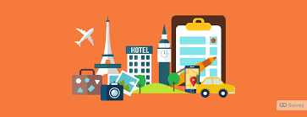

Hello Everyone!

I am student of KL University. At present I am in second year. In this year as a part of PFSD(python full stack development) course we all need to work on project called SDP(Skill Development project).These projects help us to think innovatively and work on our own. In SDP(Skill development project) we need to build or design web applications on business systems.

The business system we are currently working on is “Travel, Tourism and Hospitality”. In this article we are going to explain how we understood and planned to work on this business system.

Our team number is 03.

***Team Members:***

2100030923—Kavuluri V N K D Sai Chandana

2100031023—Syamala Likith Sai Reddy

2100030954—Dasa Sai Sneha

***Contents of this article:***

* Introduction on business system
* Persona or User Categorization.
* Empathy map
* Customer Journey Map.
* Effectiveness of the User Surveys.
* Effectiveness of the User Interviews.
* Online research links.
* Conclusion

***Introduction on business system:***

Travel and tourism industry has now become the largest civilian industry in the world. It is a source of revenue and employment. Tourism leads to creation of attractions, entertainment and better services to community with positive impact on other industries like agriculture, transport and manufacture. Moving on to Hospitalility - The hospitality industry is a broad group of businesses that provide services to customers. The industry can be broken down into three basic areas: accommodations, food and beverage, and travel and tourism. All of these areas are customer-focused, but they sometimes provide different levels of service. There are even some courses and certifications that you can learn on travel and tourism and food and beverages .

***Persona or User Categorization:***

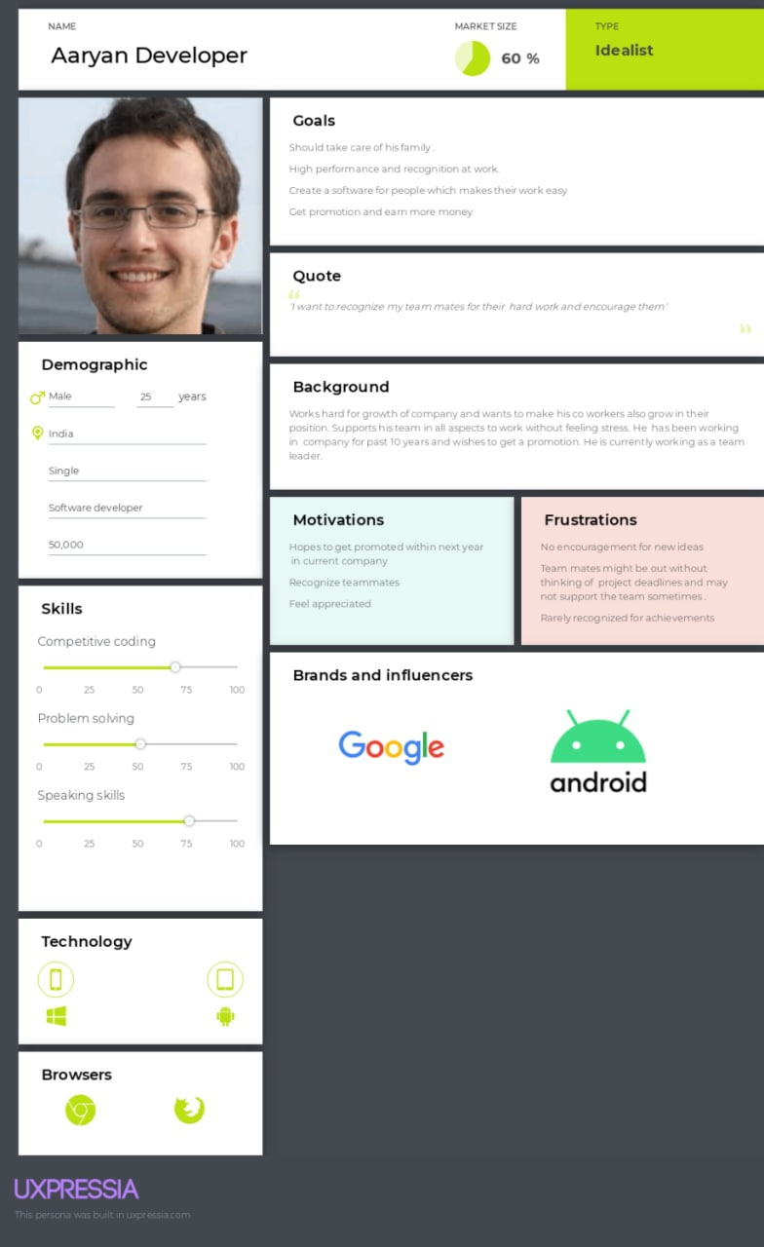

***Empathy map:***

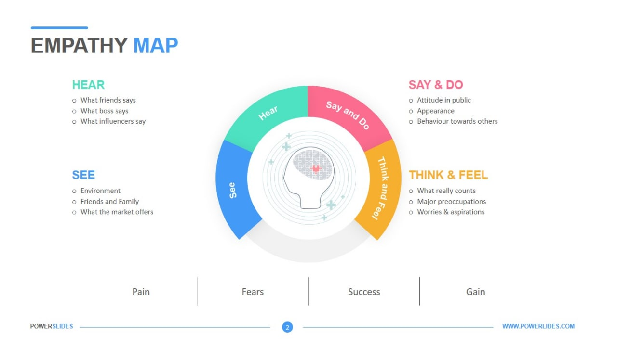

***Customer Journey Map:***

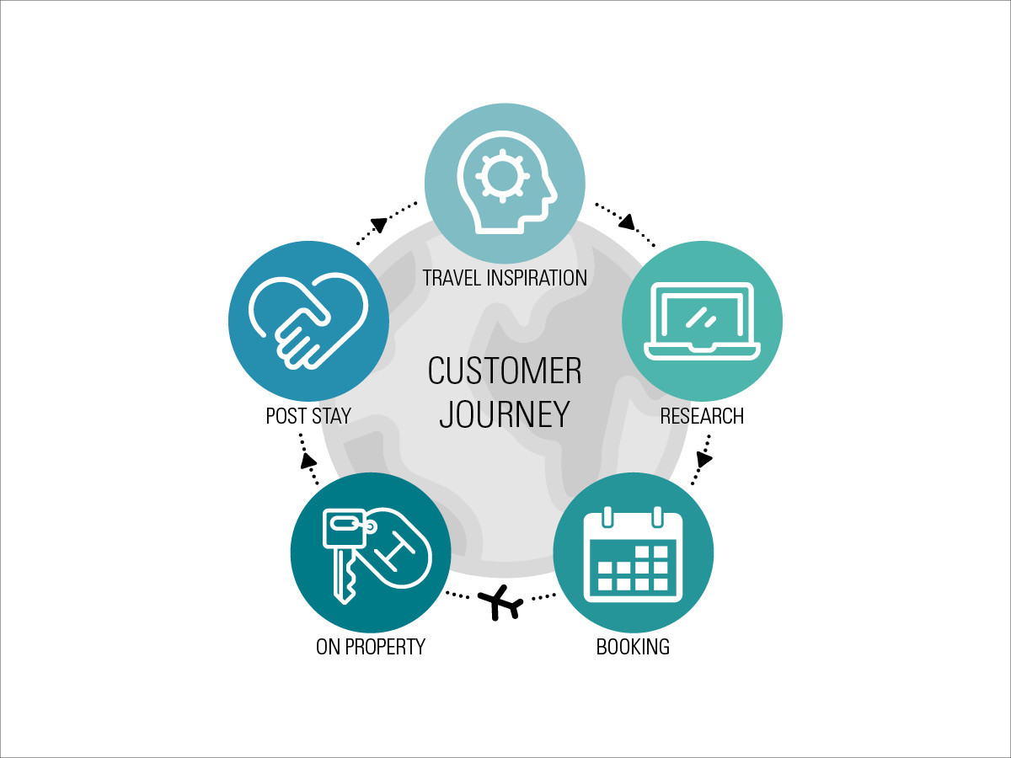

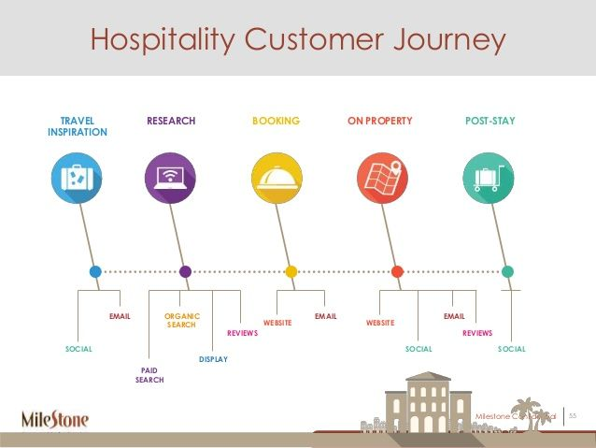

***Effectiveness of the User Surveys:***

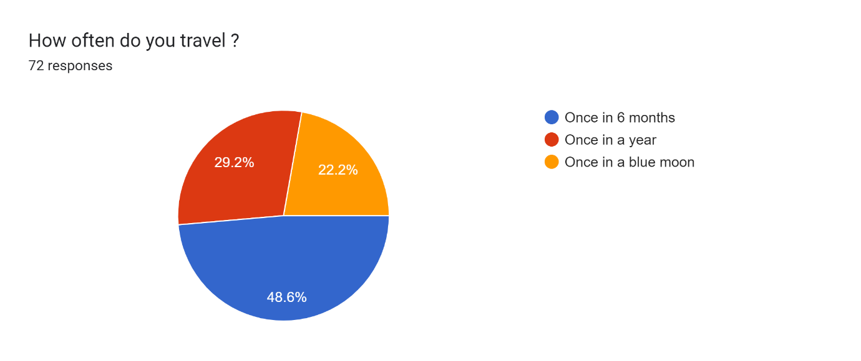

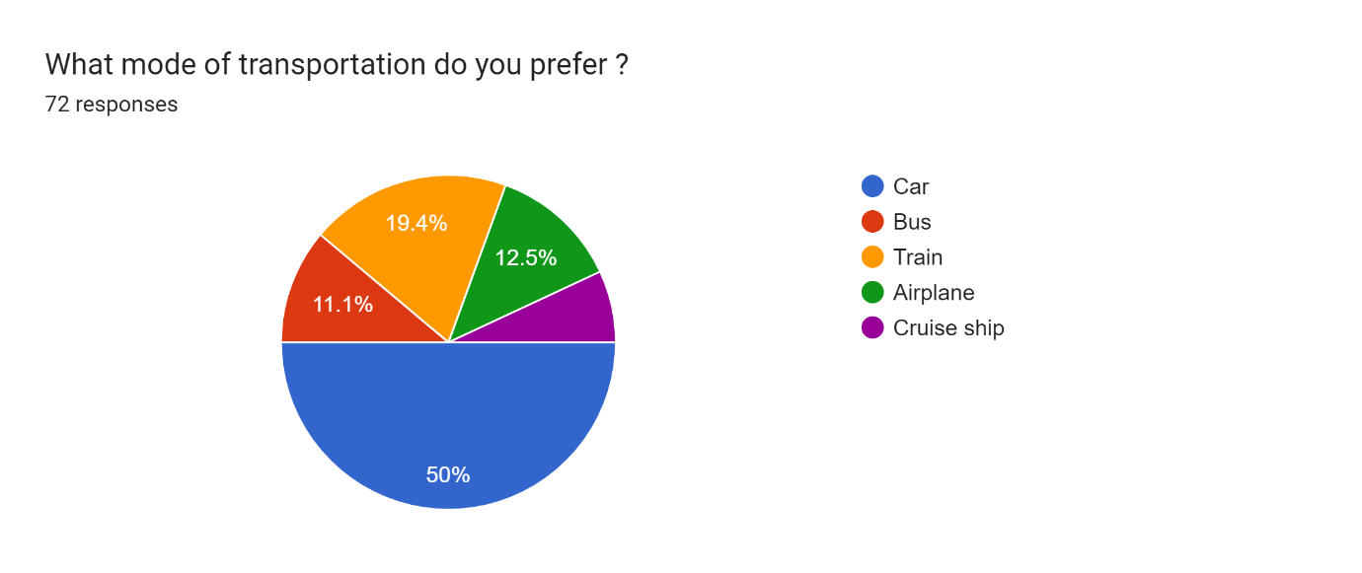

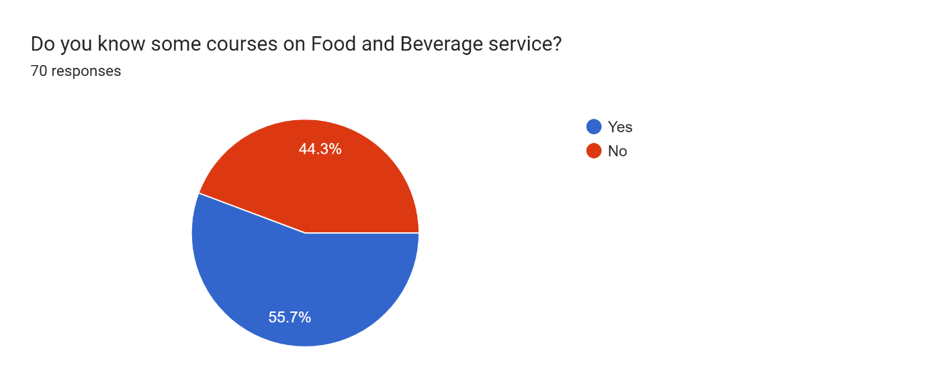

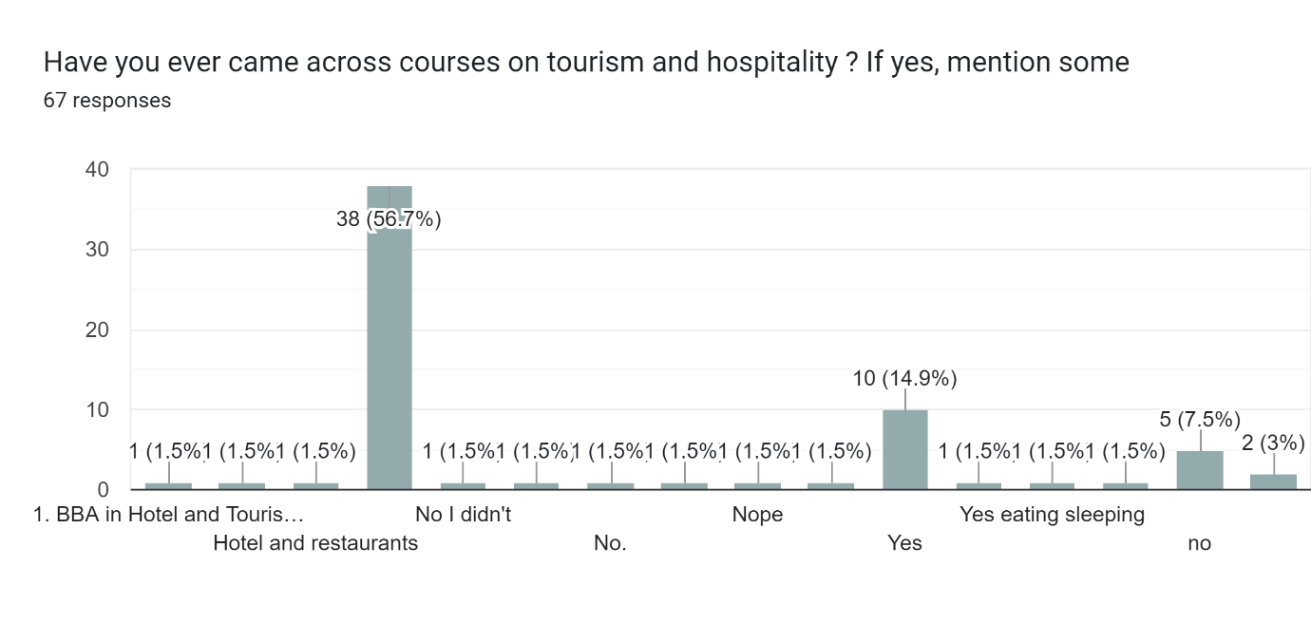

***Effectiveness of the User Interviews:***

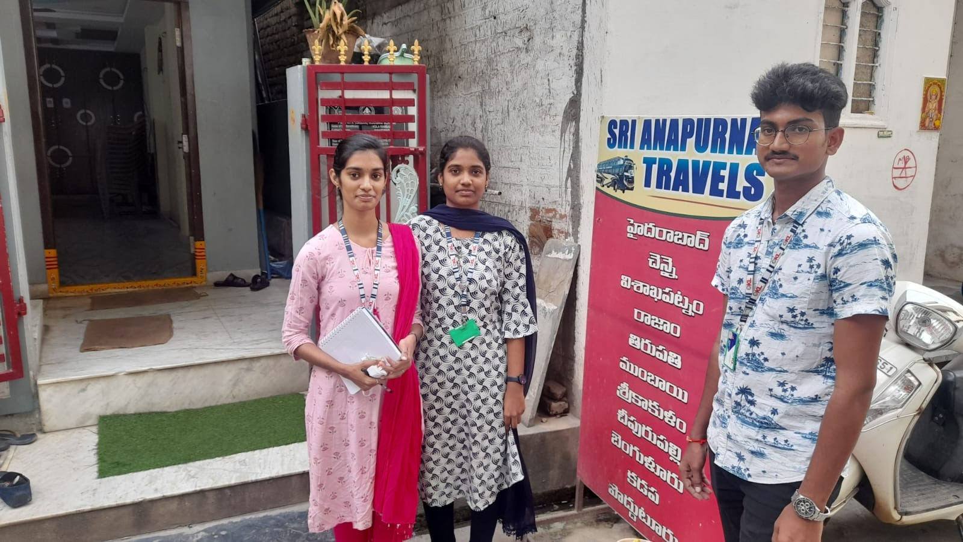

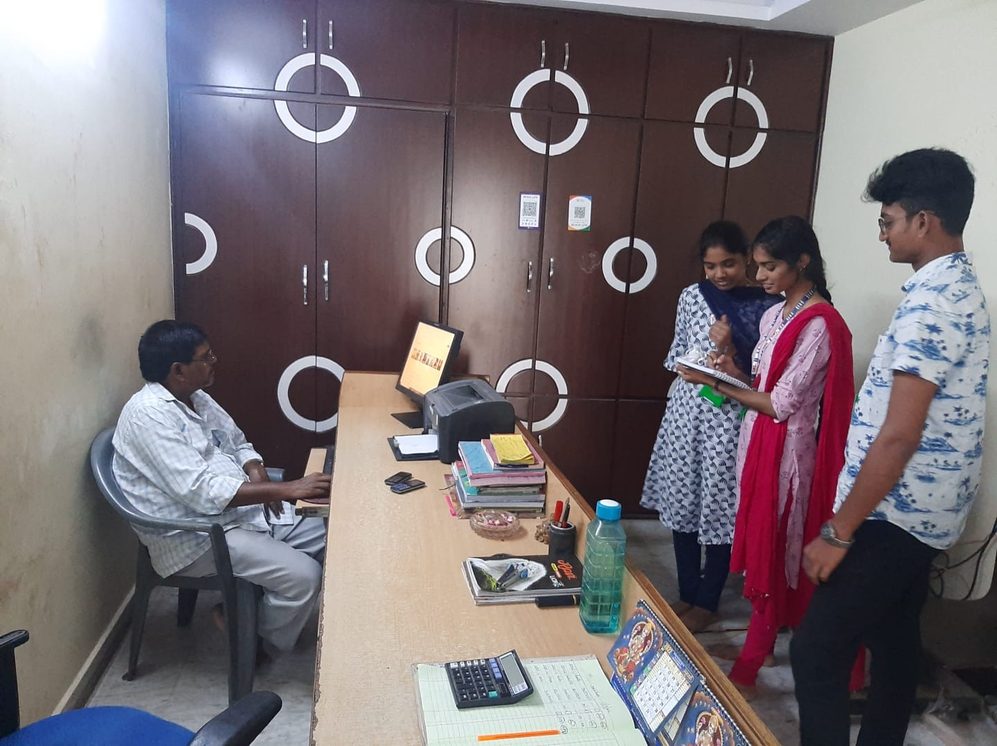

***User Requirements from field study:***

* User-friendly website
* Bus tracking facility
* More hospitality services
* More knowledgeable and skilled tour guides

***Online research links:***

[**https://www.ixigo.com/**](https://www.ixigo.com/)

[**https://www.redbus.in/**](https://www.redbus.in/)

[**https://www.makemytrip.com/**](https://www.makemytrip.com/)

**https://www.revfine.com/travel-and-tourism/**

***Conclusion:***

Through this survey we learned how to develop an user friendly website for the given business system. We want to design a website which meets user requirements and easy to use. We learned more about Travel, Tourism and Hospitality.